|  |  |
| --- | --- |
| Name of the Student | Smeet Patel |
| Roll Number | 19BCP131 |
| Complete Address of the Industry/R&D Organization where a student is working  (if applicable) | Name of the organization: - Lucent Innovation.  Address: - 815-820, Sharan Business Circle, Zundal - Tragad Rd, Chandkheda, Ahmedabad, Gujarat 382427 |
| Name of the Supervisor  from PDEU | Rajendra Chaudhary |
| Email of the Supervisor from the Industry (if  applicable) | [aman@lucentinnovation.com](mailto:aman@lucentinnovation.com) |
| Mobile Number of the Supervisor from the Industry (if applicable) | 7089490890 |
| Role | Trainee software developer role. |
| Problem Statement | NFT Marketplace App |

Basic Details:

Week – 1 (HTML, CSS, JS):

Task -1:

* Make a square of 500pxX 500px and then make a boll and Move it inside box Continuously using set Interval and if else condition.
* Now create start, pause, Reset three button and checkbox for loop. Ball should move only when start button is clicked, ball should stop at a Same position When pause is clicked. And ball should go at it first position when Reset is clicked. if loop is checked than ball should move Continuously for multiple Iteration like bottom to top in snack movement and start again from the bottom when it reaches at top And if it is unchecked than only one Iteration.
* When we click on pause, store the ball position in local storage or session storage. And use that position when user leave the page and come again or refresh the page
* Make a clock on screen using JS.
* Make a input box, plus and minus buttons for users can give a time in seconds for ball to complete on iteration.

Task-2:

* They give me an orders API and I need to extract the useful information and it should be a single page application without ReactJS. So, users can see all the orders and can also see all the products inside particular order.

Week-2,3 (ReactJS)

Task-1:

* Customer’s Profile Checkout: With the help of this application, they can check their details, edit their details, they can change their default address, check all orders, also all products in particular order. And it must be single page application.

Task-2:

* Shopping card or order list: Users can add and remove product from card and also store the card data. So, in case user leave the page or refresh the page card data should be there.

Week-3, 5 (MySQL)

Task-1:

* + ER, Relational Diagram and database for School Management System
  + Learn the advance concept of SQL like Triggers, Stored Procedures, Indexes, locking, database export-import, create user and give different privileges and more…

ER Diagram:

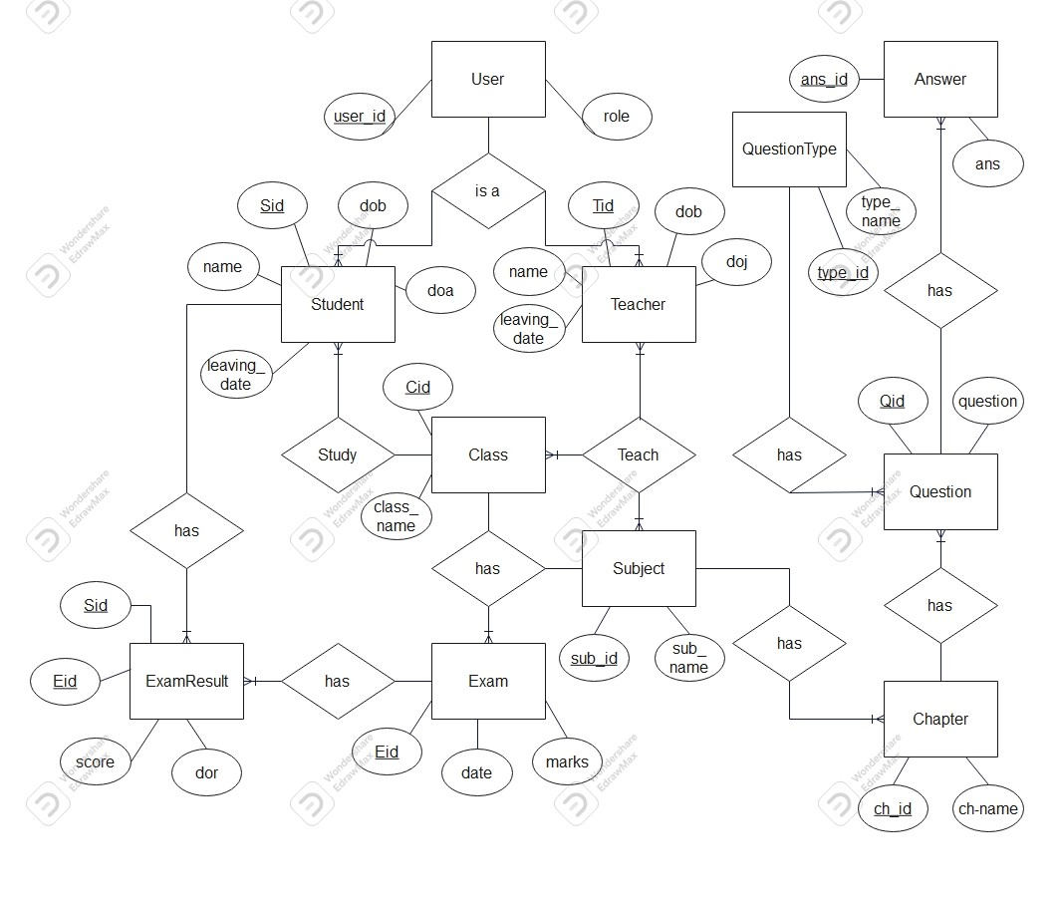

Relational Diagram:

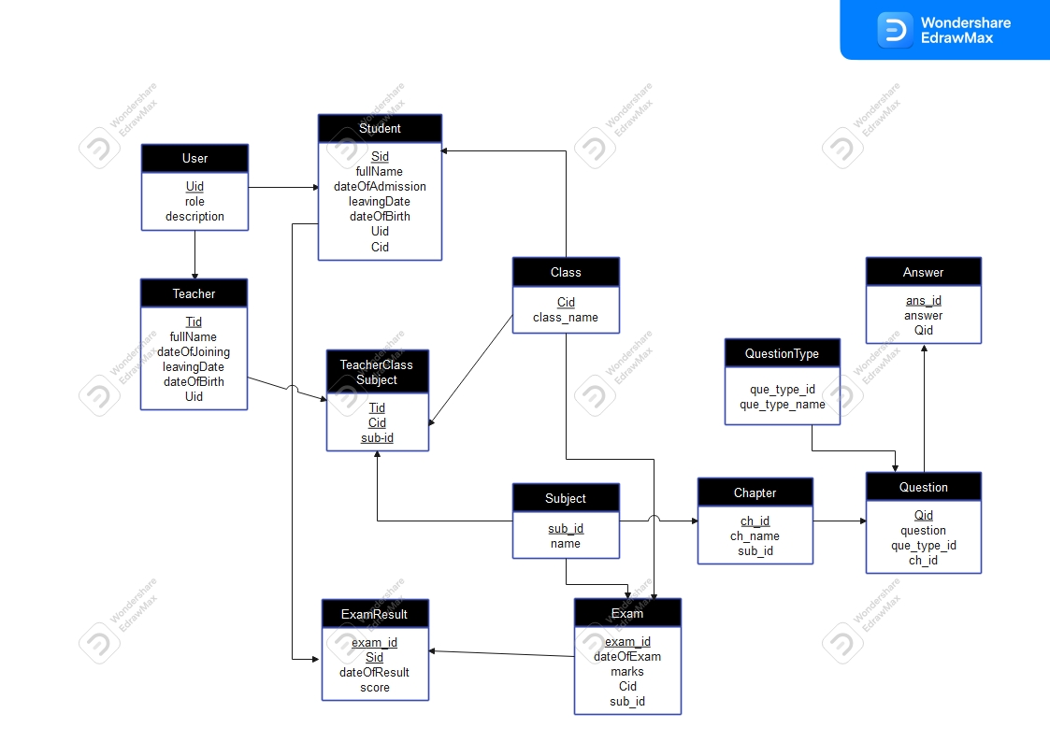

Task-2:

* + Created a SQL database with data from JSON file (NoSQL).